深 圳 大 学 实 验 报 告

课程名称： Database System

实验项目名称： Data Modelling using PowerDesigner

学院： Computer Science and Software Engineering

专业： Software Engineering

指导教师： Basker George

报告人_____________学号：______班级：___________

实验时间： 13th November, 2019

实验报告提交时间： 4th December, 2019

教务部制
实验目的与要求：(Purpose of Experiment purpose and Requirements)
* Please show all work for these problems.
Just writing down the answer will not get full credit.

Transform the following ER diagram into Relations and Create the required tables using Oracle / MySQL: (with Primary Key, Foreign Key if any, Data types, Width, Domain and Integrity Constraints )

Identify the following
- Identify the type of relationship (1:1, 1:m, m:m)
- Identify the cardinality (Min, Max)
- Primary Key

EER diagram 1):

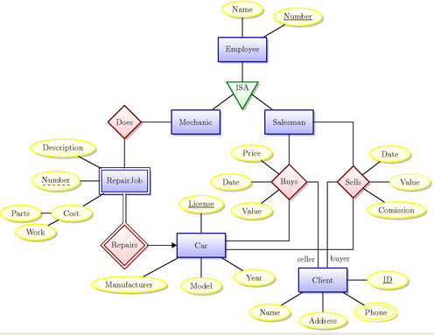

Case Study
A relational database is to be designed for a medium sized Company dealing with developing application software. The Company delivers various products to its customers ranging from a single application program to customized software. The Company employs various experts, consultants and supporting staff. All personnel are employed on long-term basis, i.e. there are no short-term or temporary staffs.

Although the Company is somehow structured for administrative purposes (that is, it is divided into departments headed by department managers) all projects are carried out in an inter-disciplinary way. For each project has a Start date when a project team is selected, grouping employees from different departments, and a Project Manager (also an employee of the Company) is appointed who is entirely and exclusively responsible for the control of the project, quite independently of the Company’s hierarchy. The following is a brief statement of some facts and policies adopted by the Company.
Entities
- Department
- Employee
- Skills
- Team
- Customers
- Product
- Projects
- Spouse
- Dependent(children of employee)

Relationships
- Employees work for different department headed by a Manager
- Employee has Spouse and Dependent (child)
- Each department manages many employees.
- Employees are divided into many teams
- Each Team manages a project
- Each Department is Headed by a Department Manager
- Each Employees belongs to one team
- A Project is headed by Project Team
- Skills are used in projects

实验过程及内容：(Methods and steps)
- Identify all entities you can think of
- Identify all the attributes
- Identify atomic, composite and derived attributes
- Identify Primary key or Composite Primary Key
- Identify all relationships between the entities
- Identify any attributes for relationship
- Identify the type of relationship (1:1, 1:m, m:m)
- Identify the cardinality (Min, Max)
Draw the Logical Data Model and Physical Data Model for Oracle DBMS using Power Designer

深圳大学学生实验报告用纸

指导教师批阅意见：

成绩评定：

指导教师签字：Basker George
2019年12月 04 日
备注：
注：1、报告内的项目或内容设置，可根据实际情况加以调整和补充。
2、教师批改学生实验报告时间应在学生提交实验报告时间后10日内。

